ONEWAY CRT BY FPS
/STATISTICS DESCRIPTIVES HOMOGENEITY WELCH
/PLOT MEANS
/MISSING ANALYSIS.

Oneway

Notes
Output Created |  | 06-May-2019 00:01:50
Comments
Input | Active Dataset | DataSet0
Input | Filter | <none>
Input | Weight | <none>
Input | Split File | <none>
Input | N of Rows in Working Data File | 30
Missing Value Handling | Definition of Missing | User-defined missing values are treated as missing.
Missing Value Handling | Cases Used | Statistics for each analysis are based on cases with no missing data for any variable in the analysis.
Syntax |  | ONEWAY CRT BY FPS  /STATISTICS DESCRIPTIVES HOMOGENEITY WELCH  /PLOT MEANS  /MISSING ANALYSIS.
Resources | Processor Time | 00 00:00:00.188
Resources | Elapsed Time | 00 00:00:00.164

[DataSet0]

Descriptives
 | N | Mean | Std. Deviation | Std. Error | 95% Confidence Interval for Mean
 |  |  |  |  | Lower Bound | Upper Bound
30 FPS | 13 | 9.0615 | 3.41895 | .94825 | 6.9955 | 11.1276
60 FPS | 17 | 8.3118 | 3.31472 | .80394 | 6.6075 | 10.0160
Total | 30 | 8.6367 | 3.32291 | .60668 | 7.3959 | 9.8775

Descriptives
 | Minimum | Maximum
30 FPS | 3.20 | 13.20
60 FPS | 4.40 | 14.00
Total | 3.20 | 14.00

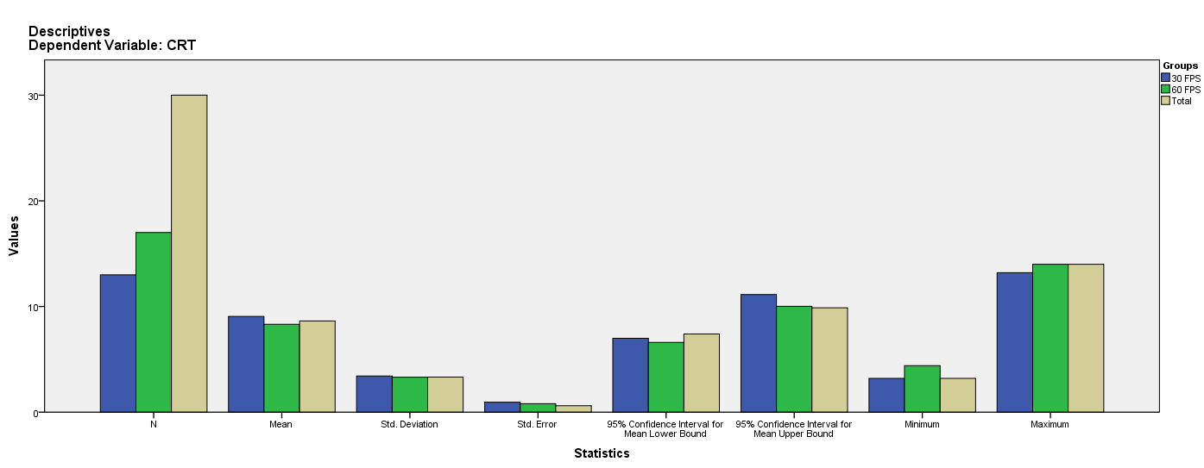

Test of Homogeneity of Variances
CRT
Levene Statistic | df1 | df2 | Sig.
.173 | 1 | 28 | .681

ANOVA
CRT
 | Sum of Squares | df | Mean Square | F | Sig.
Between Groups | 4.141 | 1 | 4.141 | .367 | .550
Within Groups | 316.068 | 28 | 11.288
Total | 320.210 | 29

Robust Tests of Equality of Means
CRT
 | Statisticª | df1 | df2 | Sig.
Welch | .364 | 1 | 25.550 | .552
a. Asymptotically F distributed.

Means Plots

